**MODEL MONITOR**

**Analysis of the Impact of Maternal Education on Child Malaria Rates**

Abstract

The purpose of this paper is to analyze the impact of maternal education on child malaria rates through a detailed approach . It uses sophisticated data analysis and predictive model, starting with data collection from UNICEF. The research involves careful and brilliant data processing and feature engineering, utilizing advanced machine learning techniques for modeling relationships between other features and nationality. Complete use of evaluation metrics like mean absolute error(MAE) and root mean square error(RMSE) for proper evaluation of the model. This model helped us to get deeper insight into our data and it also assured us that our data was properly processed leading to correct analysis of our data The findings provides insight on maternal education and also why targeted interventions are important. The paper also provides an applicable method for enhancing prediction robustness and reliability for informed decision-making in affected regions.

**INTRODUCTION**

This paper underscores the importance of maternal education to child’s malaria rate emphasizing the role an educated mother plays in the health of her child. The exploration aims to shed more light on these complexities, offering insights for policy makers and voluntary organizations to put into consideration these insights in order to reduce malaria rate in under 5 children especially in developing countries. By understanding the importance of educating women, the paper envision a future where education is made a priority and necessary interventions put in place to improve the problem.

The research delves deeper into checking the correlation between rural areas and maternal education, and also urban areas and maternal education. This gave me a different insight as to why steps for intervention will be important. The objective is to analyze the relationship between maternal education and child malaria rates and also to build model to get deeper insight on the data in order to find patterns for intervention to make these areas have lower malaria rates.

**Literature Review**

The literature review shows several studies focusing on analyzing the correlation between maternal education child malaria rates. Siri, J. (2012) used demographic and health survey (DHS) on malaria risk indicator survey, (MIS) data from eight countries in sub-Saharan Africa to explore the relationship of malaria in children and maternal education. Norton et al. [2] utilized a number of statistical techniques to tease out the effects of maternal education on both preventive care and presence of childhood malaria. Cederlund et al. [3] did a cross-sectional study that utilized Demographic and Health surveys (DHS) data. Data on 2,622 malaria positive children were used, and a logistic regression analysis was conducted to determine the association with maternal level of education. Studies comparing major developing countries have shown a positive direct association between maternal education and children’s health outcomes Martha et al.[5]. While these studies show similarities , our research distinguishes itself by employing critical analysis of not only maternal educational level, but we also used rural and urban areas to more insights into our data.

The project use the regression model to develop complex insights into the data. The evaluation using mean absolute error and root mean square error values provides insights into the goodness of fit for the model.

**Data Collection and Preparation**

i got the data sets from UNICEF DATA link: <https://data.unicef.org/topic/child-health/malaria/> . This datasets had seventeen excel sheets. It was very difficult for me to decide which of the sheets we were going to use. At first i wanted to use the MLRDIAG sheet but i could not derive insight from only that sheet. At the end, i chose MLRCARE, MLRDIAG, and MLRACT sheet. They were the only sheets that contain the informations we needed for our project. i had to process the data in order to use it with python. We processed the columns to fit into our python code. The cleaning process involved checking for null values and duplicated rows and handling them accordingly. I filtered out the required indicators i wanted to use. I cleaned the sheets separately and also analyzed and built their models different.

Data Description

1. ISO: Country code
2. Countries: Name of countries
3. UNICEF Reporting region: Region where UNICEF has explored
4. UNICEF Programme region: Programmes that has been done by UNICEF
5. World Bank income group (2022): Population’s income group
6. Year: Year of programme
7. Short Source: Source of data in abbreviation
8. Long Source: Source of data in full letters
9. National: Percentage of vulnerable children infected with malaria
10. Male: Percentage of male children population
11. Female: Percentage of female children population
12. Rural: Percentage of rural population
13. Urban: Percentage of Urban population
14. Poorest: Percentage of poor population
15. Second: Second poorest percentage of the population
16. Middle: Average poor population
17. Fourth: Fourth poorest population
18. Richest: Richest population
19. None: Percentage of women that are not educated
20. Primary: Percentage of women with primary level of education
21. Sec & Higher: Percentage of women with secondary/Higher education

**Data Visualization**

This project was thoroughly analyzed using tools such as excel and python. Below are some of my observations.

**MLRCARE** - Percentage of children (under age 5) with fever for whom advice or treatment was sought.

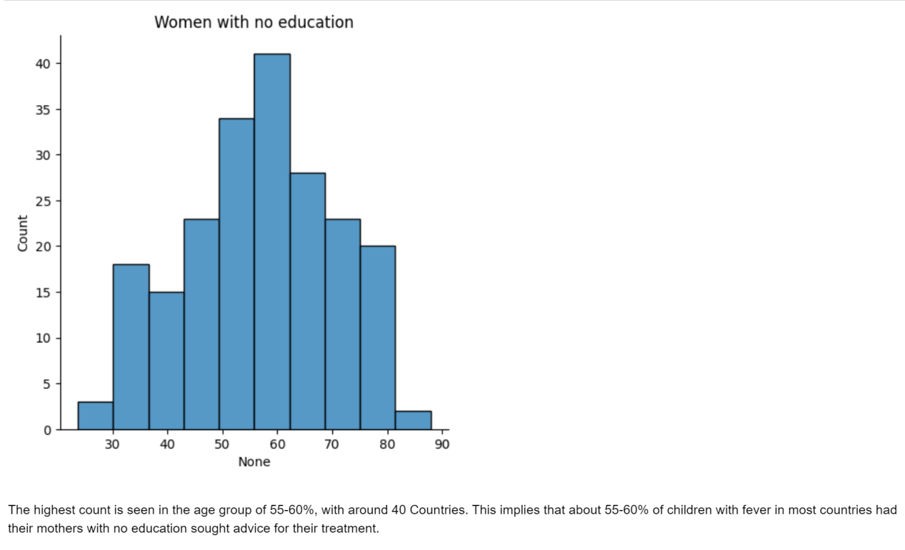

This implies that about 60% of children with fever, who got treated have uneducated mothers.

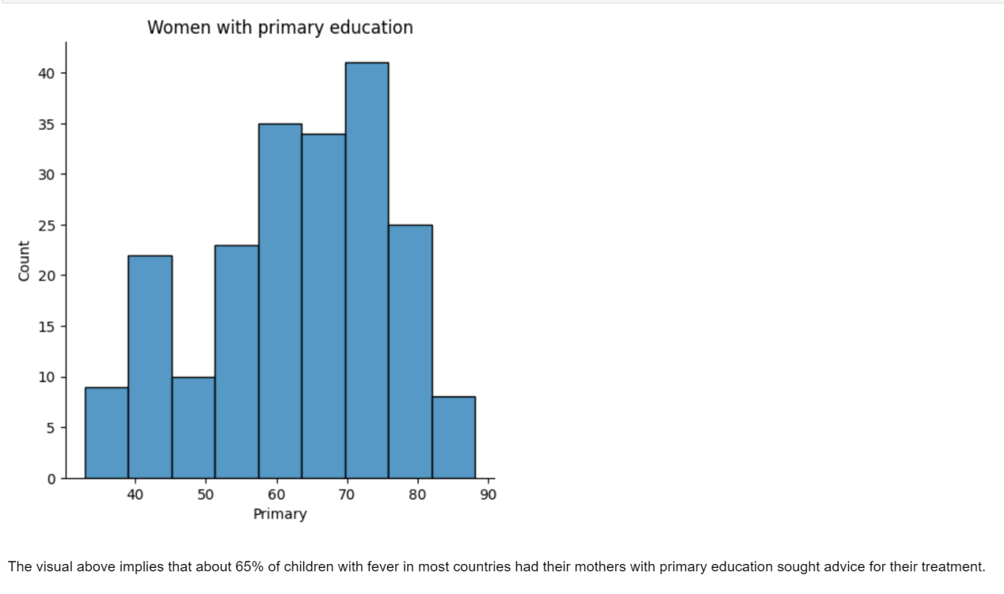

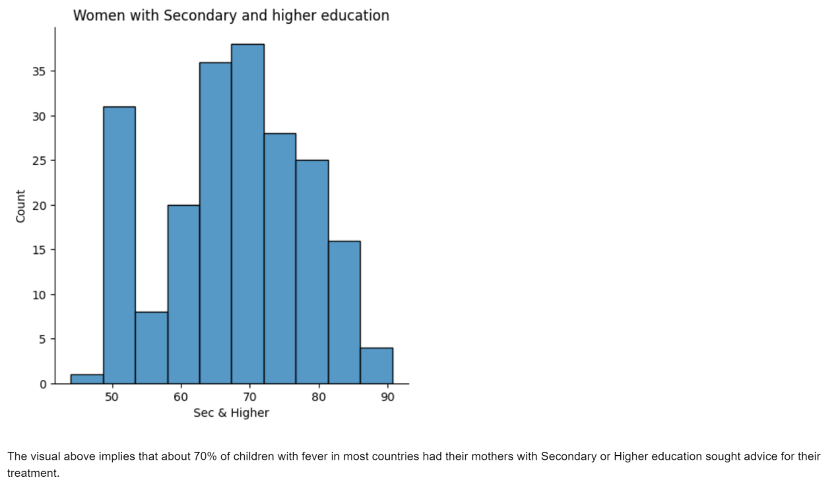

**MlRDIAG** - Malaria Diagnostics Usage-Percentage of febrile children (under age 5) who had a finger or heel stick for malaria testing.

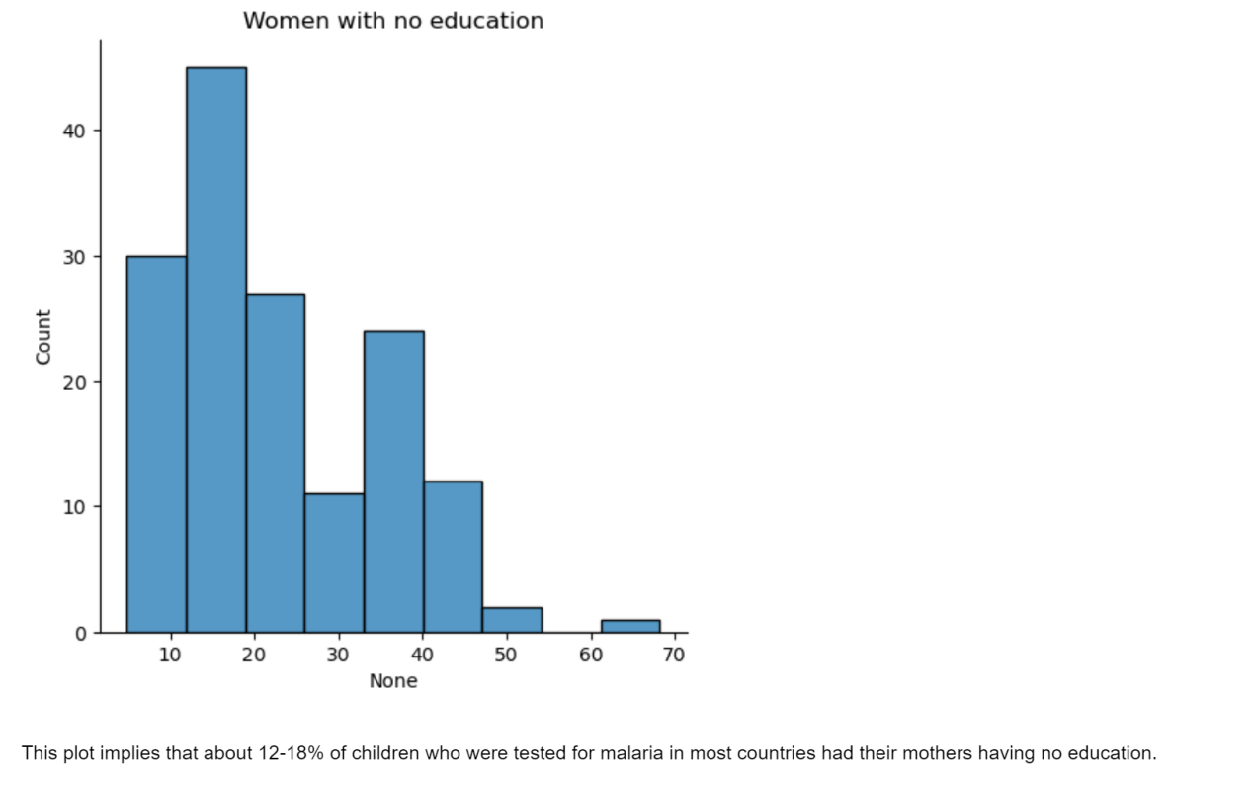

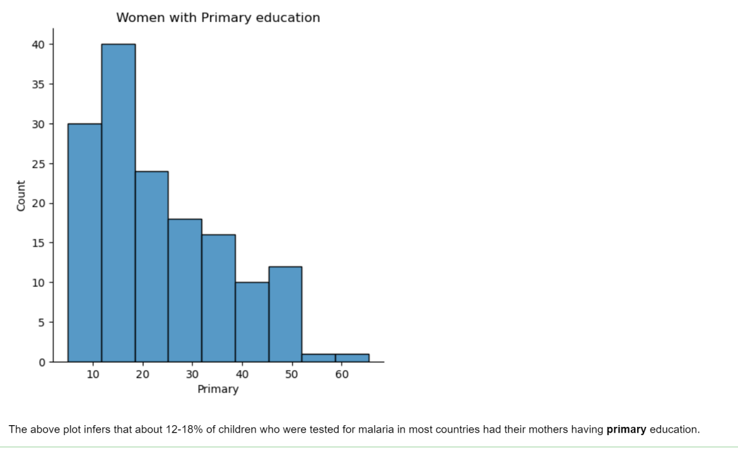

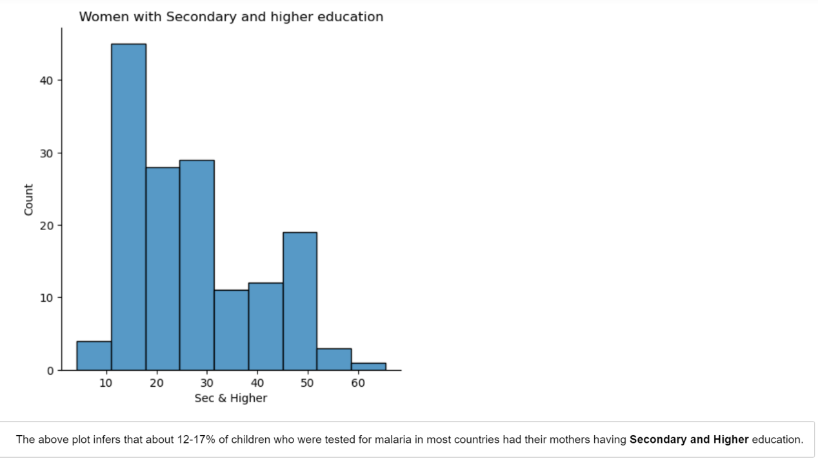

**MLRACT** - First-line treatment (ACT) for children under age 5 with fever-Percentage of febrile children (under age 5) receiving ACT (first-line antimalarial drug), among those receiving any antimalarial drugs.

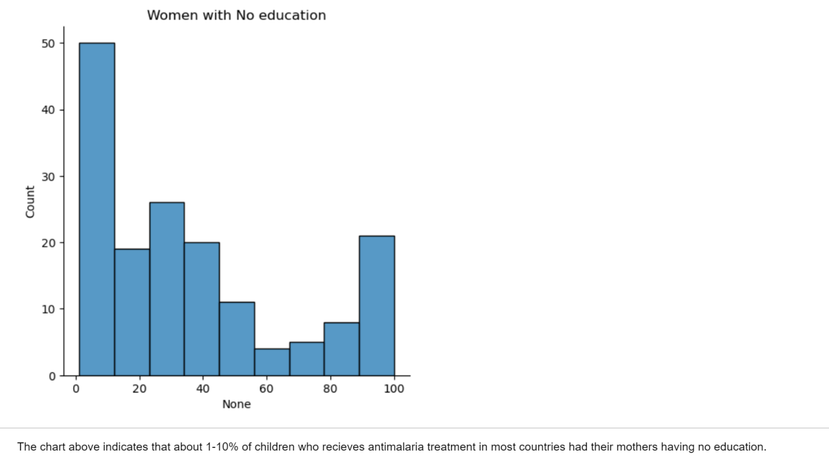

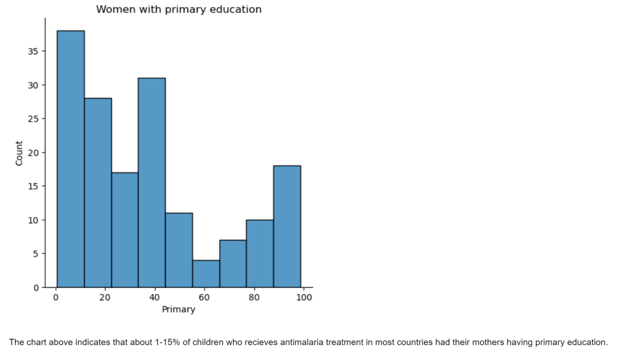

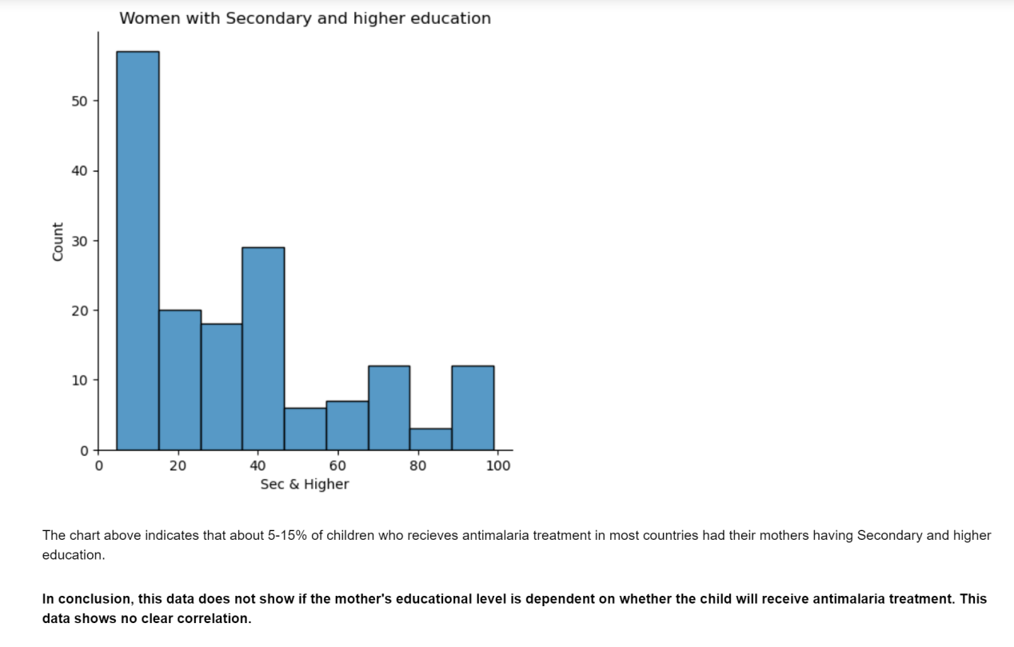

**Data Modelling**

|  |
| --- |
| **Algorithm** |
| Linear Regression |

Results:

The comprehensive analysis of the impact of maternal education on child malaria rate yielded a valuable insights that indicated that indeed maternal education has an influence in the on child malaria rate especially in vulnerable children. The critical analysis showed that more children from rural areas have uneducated mothers and these children are less likely to get treatment. It also indicate that more children from urban areas have better access to health care because they have more educated mothers. The urban area being closer to healthcare facilities makes it easier for the educated woman to access healthcare. The exploration showed diverse indicators, including nationality percentage, percentage of vulnerable children in urban and rural areas, mothers with no education, mothers with primary education and mothers with secondary and higher education.

The findings indicated that the higher a mother’s education, the lesser chance of the child being infected with malaria.

**Recommendations**:

* Build more schools in the rural areas and encourage parents in those areas to send their girls to school by making them know the importance of educating the girl child.
* A multifaceted approach that includes investment in maternal education should be taken by the government.
* Organize campaigns to teach women mostly in the rural areas the importance of using a bed net and also the importance of seeking care when her child has fever.
* Make healthcare available in the rural areas
* During pregnancy, hospitals should organize short lectures to educated women on malaria symptoms in children and the importance of treating the disease.

In conclusion, the results of this study indicate that maternal level of education was associated with the likelihood of the child positive for malaria being treated with antimalarial drugs or not. The mothers with higher education was more likely to ensure their child receives treatment with antimalarial drugs, compared to the mothers with no education.

References:

Elvis et al. <https://malariajournal.biomedcentral.com/articles/10.1186/s12936-023-04484-8>

1. Anjorin (2023) <https://malariajournal.biomedcentral.com/articles/10.1186/s12936-023-04484-8>

J. Siri, J. (2012) <https://www.ncbi.nlm.nih.gov/pmc/articles/PMC5375613/>

James Norton (2019) <https://economictimes.indiatimes.com/industry/healthcare/biotech/healthcare/maternal-education-fights-malaria-better-than-vaccine-study/articleshow/58608375.cms?from=mdr>

Martha George (2013) <https://pure.iiasa.ac.at/10261/1/IR-12-014.pdf>